附件8
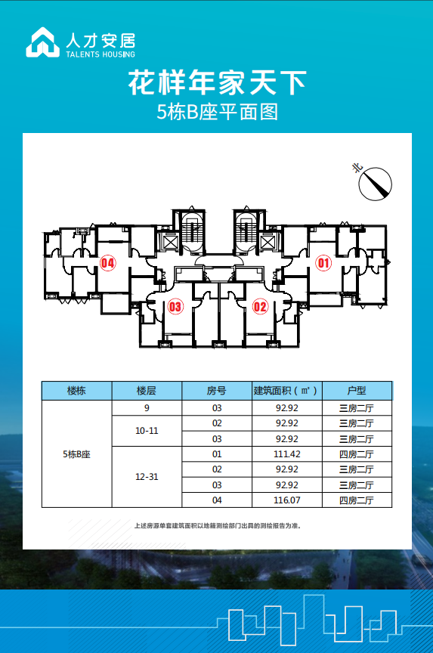
家天下花园二期平面图

